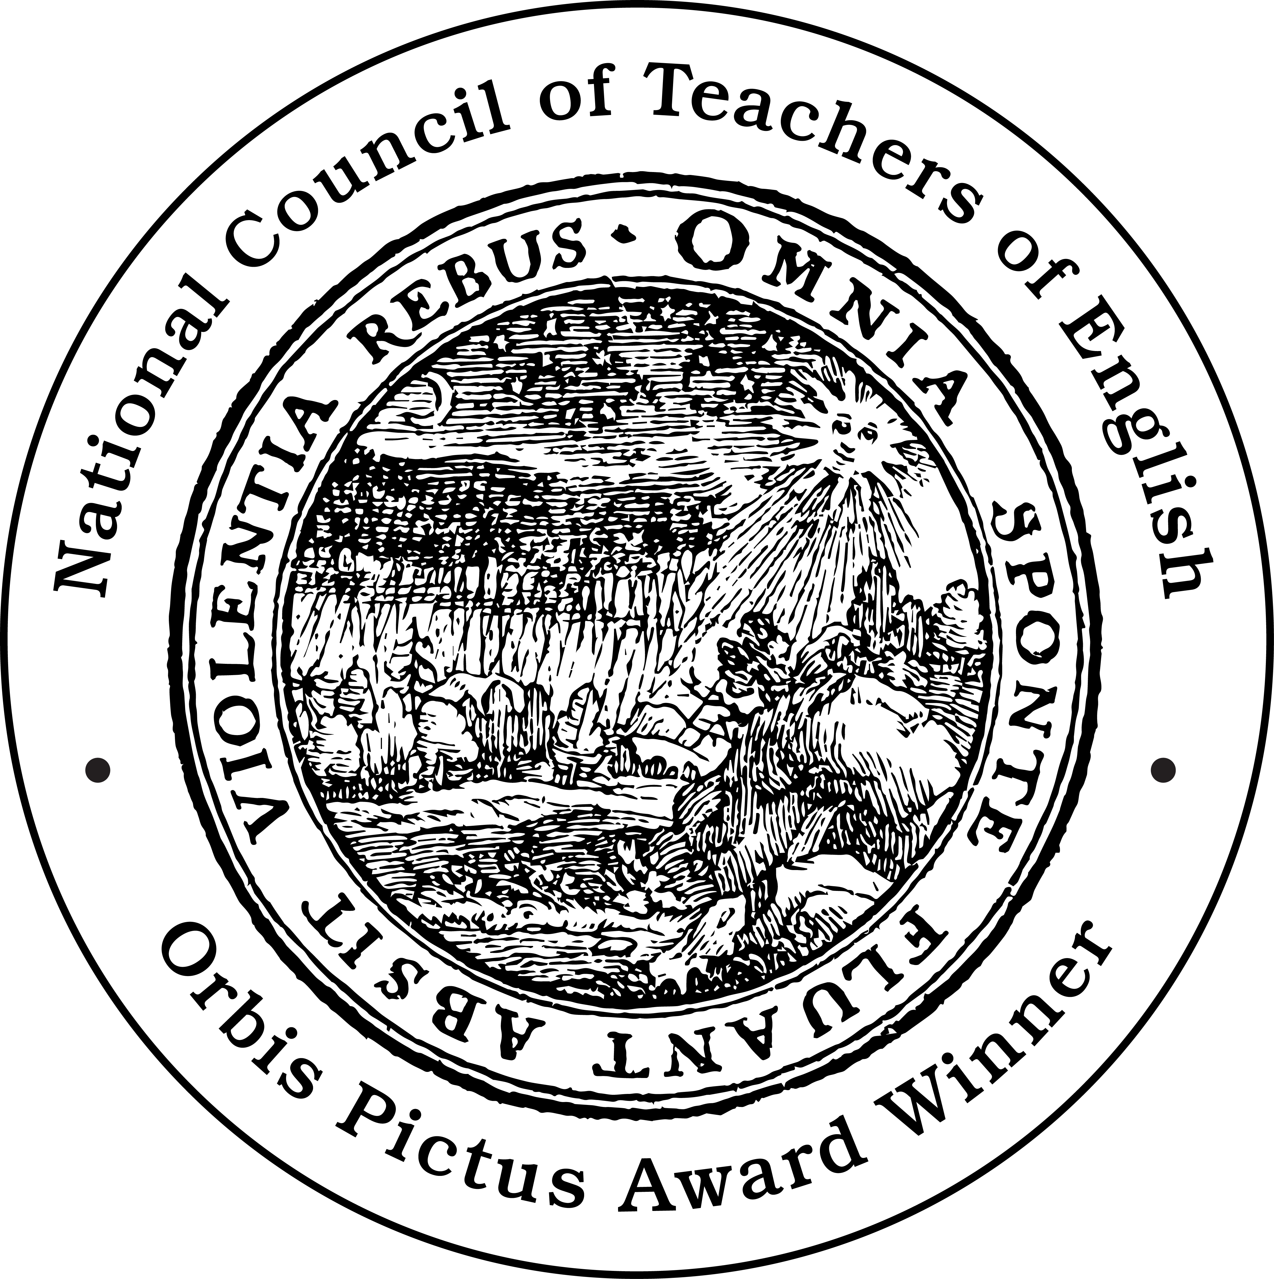
NCTE ORBIS PICTUS AWARD®

OUTSTANDING NONFICTION FOR CHILDREN

PAST WINNERS 2010-PRESENT

The award was established in 1989 to promote and recognize excellence in the writing of nonfiction for children. The name Orbis Pictus commemorates the work of Johannes Amos Comenius, Orbis Pictus—The World in Pictures (1658), considered to be the first book actually planned for children.


2020 A Place to Land: Martin Luther King Jr. and the Speech that Inspired a Nation by Barry Wittenstein, illustrated by Jerry Pinkney (Holiday House)

Honor Books:
- Manhattan: Mapping the Story of an Island by Jennifer Thermes (Abrams)
- Soldier for Equality: José de la luz Sáenz and the Great War by Duncan Tonatiuh (Harry N. Abrams)
- 1919: The Year that Changed America by Martin W. Sandler (Bloomsbury)
- The Poison Eaters: Fighting Danger and Fraud in Our Food and Drugs by Gail Jarrow (Calkins Creek)
- Planting Stories: The Life of Librarian and Storyteller Pura Belpré by Aneka Aldamuy Denise, illustrated by Paola Escobar (HarperCollins)

Recommended Books:
- The First Dinosaurs: How Science Solved the Greatest Mystery on Earth by Ian Lendler, illustrated by C. M. Butzer (Margaret K. McElderry Books/S&S)
- Beware of Crocodile by Martin Jenkins, illustrated by Satoshi Kitamura (Candlewick Press)
- Let 'Er Buck: George Fletcher, the People's Champion by Vaunda Micheaux Nelson, illustrated by Gordon C. James (Carolrhoda Books)
- Todos Iguales / All Equal: Un corrido de Lemon Grove / A Ballad of Lemon Grove by Christy Hale (Lee & Low)
- It Began with a Page: How Gyo Fujikawa Drew the Way by Kyo Maclear, illustrated by Julie Morstad (HarperCollins)
- Crossing on Time: Steam Engines, Fast Ships, and a Journey to the New World by David Macaulay (Roaring Brook Press)
- Queen of Physics: How Wu Chien Shiung Helped Unlock the Secrets of the Atom by Teresa Robeson, illustrated by Rebecca Huang (Sterling)
- Humanimal: Incredible Ways Animals Are Just Like Us! by Christopher Lloyd, illustrated by Mark Ruffle (What on Earth Books)

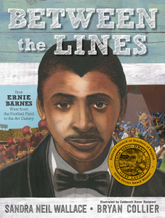
2019 Between the Lines: How Ernie Barnes Went from the Football
Field to the Art Gallery by Sandra Neil Wallace, illustrated by Bryan Collier (Simon & Schuster)

Honor Books:
- Champion: The Comeback Tale of the American Chestnut Tree by Sally M. Walker (Henry Holt and Company)
- Pass Go and Collect $200: The Story of How Monopoly was Invented by Tanya Lee Stone, illustrated by Stephen Salerno (Henry Holt and Company)
- The Secret Kingdom: Nek Chand, a Changing India, and a Hidden World of Art by Barb Rosenstock, illustrated by Claire A. Nivola (Candlewick Press)
- Thirty Minutes Over Oregon: A Japanese Pilot’s World War II Story by Marc Tyler Nobleman, illustrated by Melissa Iwai (Clarion Books)
- We are Grateful: Otsaliheliga by Traci Sorrel, illustrated by Frané Lessac (Charlesbridge Publishing)

Recommended Books:
- Boots on the Ground: America’s War in Vietnam by Elizabeth Partridge (Viking)
- Facing Frederick: The Life of Frederick Douglass, a Monumental Man by Tonya Bolden (Abrams Books for Young Readers)
- Game Changers: The Story of Venus and Serena Williams by Lesa Cline-Ransome, illustrated by James E. Ransome (Simon & Schuster/Paula Wiseman Books)
- Joan Procter, Dragon Doctor: The Woman Who Loved Reptiles by Patricia Valdez, illustrated by Felicita Sala (Alfred A. Knopf)
- Nothing Stopped Sophie: The Story of the Unshakable Mathematician Sophie Germain by Cheryl Bardoe, illustrated by Barbara McClintock (Little, Brown Books for Young Readers)
- Otis and Will Discover the Deep: The Record-Setting Dive of the Bathysphere by Barb Rosenstock, illustrated by Katherine Roy (Little, Brown Books for Young Readers)
- Something Rotten: A Fresh Look at Roadkill by Heather L. Montgomery, illustrated by Kevin O’Malley (Bloomsbury Children’s Books)
- What Do You Do with a Voice Like That?: The Story of Extraordinary Congresswoman Barbara Jordan by Chris Barton, illustrated by Ekua Holmes (Beach Lane Books)

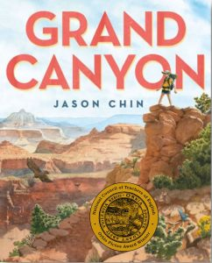
2018 Grand Canyon by Jason Chin (Roaring Brook Press)

Honor Books:
- Chef Roy Choi and the Street Food Remix by Jacqueline Briggs Martin and June Jo Lee, illustrated by Man One (Readers to Eaters)
- Dazzle Ships: World War I and the Art of Confusion by Chris Barton, illustrated by Victo Ngai (Millbrook Press)
- Her Right Foot by Dave Eggers, illustrated by Shawn Harris (Chronicle Books)
- The Quilts of Gee’s Bend by Susan Goldman Rubin (Abrams Books for Young Readers)
- The World is Not a Rectangle: A Portrait of Architect Zaha Hadid by Jeanette Winter (Beach Lane Books)

Recommended Books:
- Danza! Amalia Hernández and El Ballet Folklórico de México by Duncan Tonatiuh (Dreamscape Media)
- Fault Lines in the Constitution by Cynthia Levinson and Sanford Levinson (Peachtree Publishers)
- If Sharks Disappeared by Lily Williams (Roaring Brook Press)
- Isaac the Alchemist: Secrets of Isaac Newton, Reveal’d by Mary Losure (Candlewick Press)
- Life on Surtsey: Iceland’s Upstart Island by Loree Griffin Burns (Houghton Mifflin Harcourt)
- Maya Lin: Thinking With Her Hands by Susan Goldman Rubin (Chronicle Books)
- The Music of Life: Bartolomeo Cristofori & the Invention of the Piano by Elizabeth Rusch, illustrated by Marjorie Priceman (Atheneum Books for Young Readers)
- The Whydah: A Pirate Ship Feared, Wrecked, and Found by Martin W. Sandler (Candlewick Press)

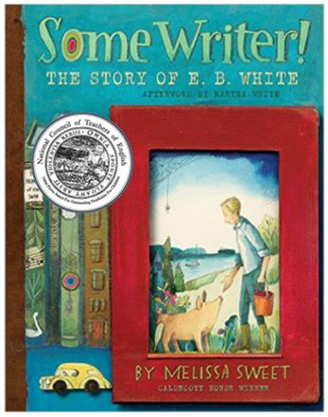
2017 Some Writer!: The Story of E.B. White
by Melissa Sweet (Houghton Mifflin Harcourt Books for Young Readers)

Honor Books:
- Animals by the Numbers: A Book of Animal Infographics by Steve Jenkins (Houghton Mifflin Harcourt Books for Young Readers)
- The First Step: How One Girl Put Segregation on Trial written by
Susan E. Goodman, illustrated by E. B. Lewis (Bloomsbury)
- Giant Squid by Candace Fleming, illustrated by Eric Rohmann
(Roaring Brook Press)
- I Dissent: Ruth Bader Ginsburg Makes Her Mark by Debbie Levy, illustrated by Elizabeth Baddeley (Simon & Schuster Books for Young Readers)
- ¡Olinguito, de la A a la Z!: Descubriendo el bosque nublado / Olinguito, from A to Z: Unveiling the Cloud Forest by Lulu Delacre (Children’s Book Press)

Recommended Books:

- Ada Lovelace, Poet of Science: The First Computer Programmer by Diane Stanley, illustrated by Jessie Hartland (Simon & Schuster Books for Young Readers)
- Ada’s Violin: The Story of the Recycled Orchestra of Paraguay by Susan Hood, illustrated by Sally Wern Comport (Simon & Schuster Books for Young Readers)
- Comics Confidential: Thirteen Graphic Novelists Talk Story, Craft, and Life Outside the Box compiled and edited by Leonard Marcus (Candlewick Press)
- Dive!: World War II Stories of Sailors & Submarines in the Pacific by Deborah Hopkinson (Scholastic)
- How to Build a Museum: Smithsonian’s National Museum of African American History and Culture by Tonya Bolden (Viking Books for Young Readers)
- Miss Mary Reporting: The True Story of Sportswriter Mary Garber by Sue Macy, illustrated by C. F. Payne (Simon & Schuster Books for Young Readers)
- Sachiko: A Nagasaki Bomb Survivor’s Story by Caren Stelson (Carolrhoda)
- Step Right Up: How Doc and Jim Key Taught the World about Kindness by Donna Janell Bowman, illustrated by Daniel Minter (Lee & Low Books)

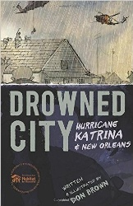
2016 Drowned City: Hurricane Katrina & New Orleans
by Don Brown (Houghton Mifflin Harcourt Books for Young Readers)

Honor Books:
- Funny Bones: Posada and His Day of the Dead Calaveras by Duncan Tonatiuh
(Abrams Books for Young Readers)
- Growing Up Pedro by Matt Tavares (Candlewick)
- Mesmerized: How Ben Franklin Solved a Mystery that Baffled All of France by
Mara Rockliff, illustrated by Iacopo Bruno (Candlewick)
- Swan: The Life and Dance of Anna Pavlova by Laurel Snyder, illustrated by
Julie Morstad (Chronicle Books)
- Terrible Typhoid Mary: A True Story of the Deadliest Cook in America by Susan Campbell Bartoletti
(Houghton Mifflin Harcourt Books for Young Readers)

Recommended Books:

- Courage & Defiance: Stories of Spies, Saboteurs, and Survivors in World War II Denmark by
Deborah Hopkinson (Scholastic Press)
- Game Changer: John McLendon and the Secret Game by John Coy, illustrated by Randy DuBurke (Carolrhoda Books)
- The House that Jane Built: A Story about Jane Addams by Tanya Lee Stone, illustrated by
Kathryn Brown (Henry Holt & Company)
- Most Dangerous: Daniel Ellsberg and the Secret History of the Vietnam War by Steve Sheinkin (Roaring Brook Press)
- My Story, My Dance: Robert Battle’s Journey to Alvin Ailey by Lesa Cline-Ransome, illustrated by James E. Ransome (Simon & Schuster Books for Young Readers)
- Raindrops Roll by April Pulley Sayre (Beach Lane Books)
- Trombone Shorty by Troy “Trombone Shorty” Andrews, illustrated by Bryan Collier
(Abrams Books for Young Readers)
- W Is for Webster: Noah Webster and His American Dictionary by Tracey Fern, illustrated by
Boris Kulikov (Farrar, Straus and Giroux)

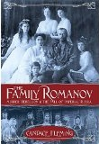
2015 The Family Romanov: Murder, Rebellion & the Fall of Imperial Russia
by Candace Fleming (Schwartz & Wade)

Honor Books:
- A Home for Mr. Emerson by Barbara Kerley illustrated by Edwin Fotheringham
(Scholastic Press)
- Mr. Ferris and His Wheel by Kathryn Gibbs Davis illustrated by Gilbert Ford
- (Houghton Mifflin Harcourt)
- The Right Word: Roget and His Thesaurus by Jen Bryant, illustrated by Melissa Sweet (Eerdmans Books for Young Readers)
- Separate is Never Equal: Sylvia Mendez & Her Family’s Fight for Desegregation
by Duncan Tonatiuh (Abrams Books for Young Readers)
- Star Stuff: Carl Sagan and the Mysteries of the Cosmos by Stephanie Roth Sisson (Roaring Brook Press)

Recommended Books:

- Eye to Eye: How Animals See the World by Steve Jenkins (Houghton Mifflin Harcourt)
- Chasing Cheetahs: The Race to Save Africa’s Fastest Cats by Sy Montgomery, photographs
by Nic Bishop (Houghton Mifflin Harcourt)
- The Girl from the Tar Paper School: Barbara Rose Johns and the Advent of the Civil Rights Movement by Teri Kanefield (Abrams Books for Young Readers)
- Little Melba and Her Big Trombone by Katheryn Russell-Brown, illustrated by Frank Morrison
(Lee & Low Books)
- Neighborhood Sharks: Hunting with the Great Whites of California’s Farallon Islands by Katherine Roy (David Macaulay Studio/Roaring Brook Press)
- The Scraps Book: Notes from a Colorful Life by Lois Ehlert (Beach Lane)
- The Streak: How Joe DiMaggio Became America’s Hero by Barb Rosenstock, illustrated by Terry Widener (Calkins Creek)
- Strike!: The Farm Workers’ Fight for Their Rights by Larry Dane Brimner (Calkins Creek)


