The Thirty-Second National African American Read-In
Sponsored by the Black Caucus of the National Council of Teachers of English and the National Council of Teachers of English

February 2021

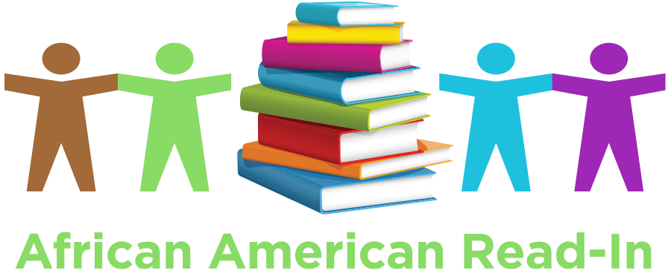

Certificate of Participation Awarded to

The African American Read-In was founded by Dr. Jerri Cobb Scott in 1990.

