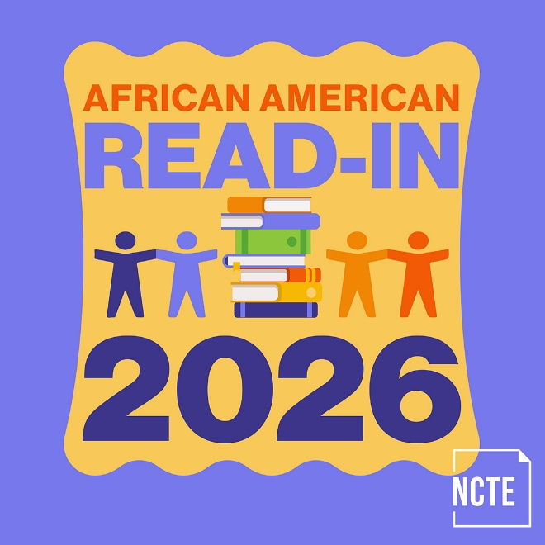
The Thirty-Seventh National
African American Read-In
Sponsored by the Black Caucus of the National Council of Teachers of English and the National Council of Teachers of English
February 2026

Certificate of Participation Awarded to

The African American Read-In was founded by Dr. Jerri Cobb Scott in 1990.

