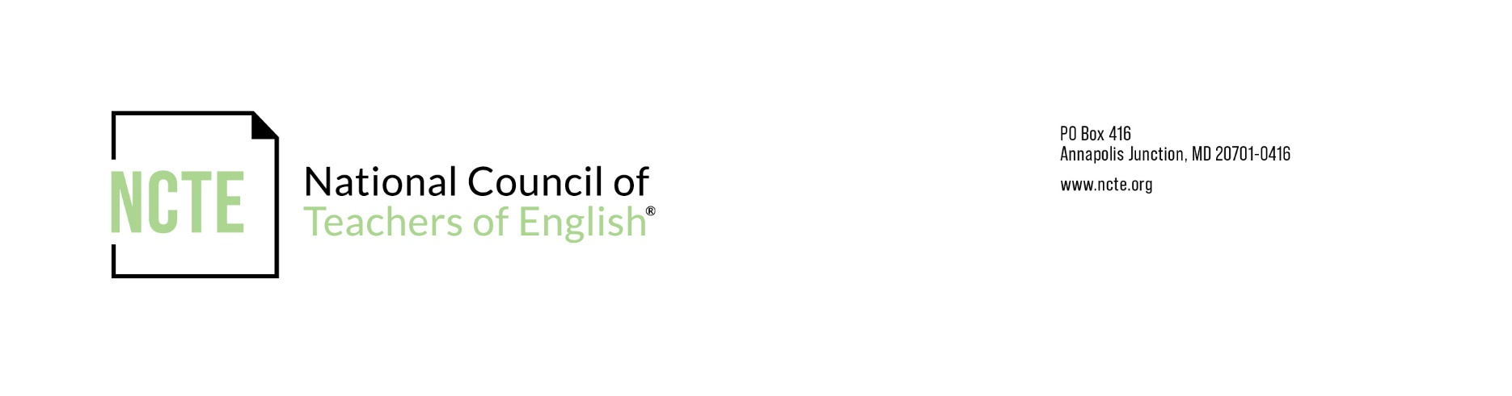
NCTE Assembly Directors Form

Director(s) will attend the Board of Directors Meeting held at the NCTE Annual Convention

PLEASE RETURN THIS FORM TO: affsec@ncte.org

NOTE: According to the NCTE Constitution, an assembly with:
- fewer than 149 NCTE members may name one director;
- 150-349 NCTE members may name two directors;
- 350-549 NCTE members may name three directors;
- 550-749 NCTE members may name four directors;
- and so on up to a maximum of six directors (constitutional amendment, 1991).
All officers, including directors, must be members of the National Council.

Full Name of Assembly:

Name of Person Submitting Report:

Position in Assembly:

Academic Year:

Date:

Include the following information for each Director.

Director’s Name:
Term of Office:
Email:

