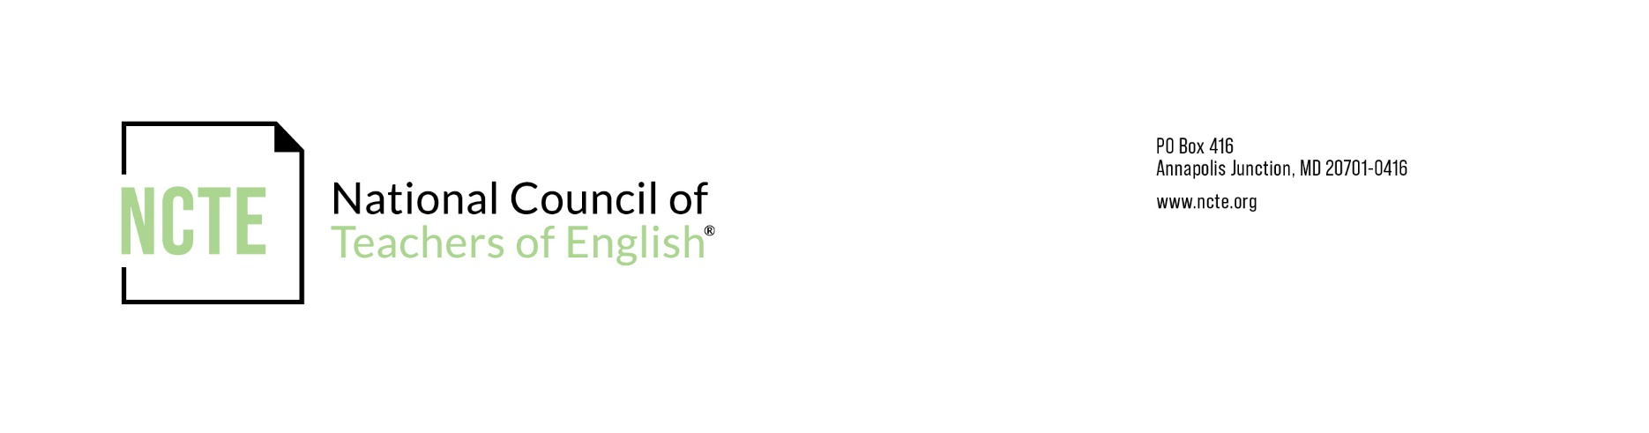
NCTE Student Affiliate Roster Statement

PLEASE SEND UPDATES AS THEY OCCUR THROUGHOUT THE YEAR!

BY SEPTEMBER 15, RETURN WITH CURRENT ROSTER TO: affsec@ncte.org

According to the rules of affiliation with NCTE described in the NCTE Constitution, Article V, Section C, the faculty sponsor and all members of the student affiliate governing board must be student members of NCTE, and the student affiliate must have at least 10 NCTE Student members. To indicate that you’ve checked with your officers to make sure they are NCTE members, please sign and return this form with your other forms.

Full Name of Student Affiliate:

Academic Year for this Statement:

_____I have checked with all the persons listed as officers, editors, and members of the governing board and they affirm that they are members of NCTE.

Name/Signature:

Position in Affiliate:

Date:

For the faculty sponsor and each student affiliate offers, please include the information requested below. Please use the format below as a sample.

Name:
Student Affiliate Role:
Term of Office:
Email:

